#### **WOLDIA UNIVERSITY COLLEGE OF AGRICULTURE, SCHOOL OF VETERINARY MEDICIN**



**STEDY ON THE PREVALENCE AND IDENTIFICATIONS OF HARD TICK IN CAMELE IN HABRU DISTRICT OF NORTH WELLO ZONE**

**BY**

**YIDERSAL TIZAZU (WDU 110484)**

**ADVISOR ABEBE BERIHUN (DVM, MSc, Assistance Professor)**

**A THESIS SUBMITTED TO THE SCHOOL OF VETERINARY MEDICINE, WOLDIA UNIVERSITY, IN PARTIAL FULFILLMENT OF THE REQUIREMENTS FOR THE DEGREE OF DOCTOR OF VETERINARY MEDICINE (DVM)**

**MAY, 2024**

**MERSA, ETHIOPIA**

**STEDY ON THE PREVALENCE AND IDENTIFICATIONS OF HARD TICK IN CAMELE IN HABRU DISTRICT OF NORTH WELLO ZONE**

**BY**

**YIDERSAL TIZAZU (WLDU 110484)**

**BOARD OF EXTERNAL EXAMINERS**

1. _________ Signature: _________Date: _______

2. _________ Signature: _________Date: _______

**Advisors:** ABEBE BERIHUN (DVM, MSc, Assistance professor)

Signature: _________

Date: _______

**TABLE OF CONTENTS**

# ACKNOWLEDGEMENTS

First of all, almighty GOD should receive glory for his endless mercy and life he provided me through his one and only son Jesus Christ.

I would like to express the most sincere thanks and profound sense of gratitude to my advisor Dr Abebe Berihun for his advice, comments for the preparation of this thesis paper.

I also want to thanks for all my families for their continuous support and I would like to my great pleasure to thanks my entire friends for their important comment and suggestion.

Lastly, I would like to acknowledge Woldia University College of Agriculture, School of Veterinary Medicine for facility support and interest access.

# LIST OF TABLES

# LIST OF FIGURES

# LIST OF ABBREVIATIONS

# LIST OF ANNEXS

# ABSTRACT

# 1. INTRODUCTIN

Ethiopia is one of the largest camel populated countries in the world. The total number of camels in the world is about 25.89 million, 89% of which are Dromedary camels, and the remaining (11%) is a Bactrian camel (in the cold deserts of Asia). More than 80% of the world's camels are found in Africa (CSA 2014). In Africa, it ranks third next to Somalia and Sudan. About 1,102,119 of camels found in Ethiopia, distributing in Southern, Eastern, North Eastern arid and semi-arid regions of the country mainly in Ogaden, Borana and Afar regions (CSA, 2013). In Ethiopia, the one humped camel (Camellus dromedarius) is an important livestock species in the pastoral economy because of its extraordinary ability to perform in arid and semi arid environments where there is scanty vegetation (Dinka et al., 2010).

Camels are considered as pseudo-ruminant, multipurpose animals uniquely adapted to arid and semi-arid environment which enables pastoralist people to live in difficult environment of the world (Scwartz, 2001). Camels are classified as mammals with double fingers and lined feet and it belongs to the family of Camelidae that included Dromedary, Bactrian, Lama, Alpaca, Vicuna and Guanaco (Franklin, 2011).

The dromedaries favor desert environments and are used in the transportation of human and also as a source of hair, hides, meat and milk (Al-Salihi, 2016). The camel plays a significant role as a primary source of subsistence in the lowlands of the country. It lives in wide arid and semi-arid areas, which are not suitable for crop production and less suitable for other livestock production. Therefore, in this part of the country the camel are superior to all other livestock in terms of food security (Dinka et al 2010). The camel's importance will increase with continuing land degradation and rapidly growing human population (Bekele, 2010).

The presence of different agro climatic zones and diversified environment makes the country suitable for different kinds of livestock disease. Ethiopia’s great livestock potential is not properly exploited due to different factors such as traditional management system, limited genetic potential, and lack of appropriate disease control policy and lack of appropriate veterinary services (EARO, 2000). A wide range of various external and internal parasitic diseases have been reported to be the major problems affecting the health, productivity and performance of domestic animals. Similar other animals, camels are highly susceptible to diseases and parasites (Al-Salihi*et al.,* 2018). The external parasites of camels are including ticks, mites, and other parasitic arthropods e.g. myiasis flies (Maha et al., 2010).

Ticks are among the most common ectoparasites and vectors of important animal diseases on a global scale particularly, in tropical and sub-tropical parts of the world (Maha et al., 2010). Ticks are obligate blood- feeding parasites of terrestrial vertebrates. They have worldwide distribution and cause tick worry, anemia, skin injury and sometimes tick paralysis during feeding on their host (Wall and Shearer, 2001).

There are two families of ticks the hard ticks (so called by virtue of their hard dorsal shield) and soft ticks (due to their flexible leathery cuticle) or the Ixodidae and Argasidae families respectively (Kassa, 2005). Ixodidae or hard ticks are obligate blood sucking arthropods it comprises approximately 80% of all tick species (Pavlovicet al., 2016). Ticks which are considered to be most importantto the health of livestock in Africa comprise about seven genera. Among these ticks, generally the main ticks found in Ethiopia include: -Amblyomma, Boophilus, Haemaphysalis, Hyalomma and Rhipicephalus. And also there are 20 species of ticks exists on livestock, all of which have damaging effect on production and productivity (Kassa, 2005; Ayele and Mohammed, 2013).

The role (importance) of ticks is very important in public health and veterinary medicine (Mullen and Durden 2009). It is importance principally due to the ability to transmit a wide spectrum of pathogenic microorganisms, such as protozoa, rickettsial, bacterial, spirochetes and viruses, and causing blood loss, irritation, inflammation, hypersensitivity and damage to hide and skin (Walker et al., 2003). They have worldwide distribution and cause tick worry, anaemia, skin injury and sometimes tick paralysis during feeding on their host (Wall and Shearer, 2001).

In Africa, tick-borne protozoan diseases (e.g. theileriosis and babesiosis), rickettsial diseases (e.g. anaplasmosis, and heart water [cowdriosis]), bacterial diseases (e.g. Tularaemia), Spirochaetes (e.g. Lyme disease = “tick- borne disease affecting human” and Relapsing fever) and Viral diseases (e.g. Louping ill and African swine fever) are the main health and management problems of livestock (Wall and Shearer, 2001). Ticks are responsible for losses caused by their attachment to animal hides, by the injection of toxins, and/or by the transmission of diseases that reduce yield (Walke*et al*., 2003).

The main effect of tick infestation in one humped camel is mild to severe anemia, loss of appetite, leading to a reduction in growth rate and decreased productivity (Mohsen et al., 2013). Additionally, ticks are responsible for direct damage to the camels through their feeding habits, damage to udders, teats and scrotum, myiasis due to infestation of damaged sites by maggots and secondary microbial infections (Abebaw, 2004).

Due to economic and veterinary importance of ticks, their control and the transmission of tick borne diseases remain a challenge in tropical and subtropical areas of the world and it is a priority for many countries in tropical and subtropical regions having various climatic zones (Lodos *et al*., 2000). Ethiopia represents having one of various climatic zones and livestock production systems in tropical Africa (Sileshi, 2014).

Numerous studies have been done on the ticks and TBDs of cattle and small ruminants in Ethiopia. However, work on the ticks of camels is scanty (Zeleke and Bekele). There was no research conducted on ectoparasites of camels in the study area, therefore, it is quite important to know the prevalence, associated risk factors and genera of ticks in camel so as to design necessary strategic prevention and control measures.

## 1.1 Objective of the Study

### *1.1.2 General objective*

* To study the prevalence, identifications, and risk factors of hard tick on camele in Habru Woreda.

### *1.1.3 Specific objective*

* To assess the major risk factors associated with the prevalence of adult hard ticks in camel in the study area.
* To determine the prevalence of adult hard ticks and identify the major ticks that infecting camel’s in the study area.
* To identify the tick species with their favorable predilection site and the tick burden in different groups of age, and body condition in Habru district

# 2. MATERIALS AND METHODS

## 2.1 Study Area

## The study will be conducted from December 2023 to May 2024 in Habru district. Habru is a [woreda](https://en.wikipedia.org/wiki/Districts_of_Ethiopia" \o "Districts of Ethiopia) in the [Amhara Region](https://en.wikipedia.org/wiki/Amhara_Region" \o "Amhara Region) of [Ethiopia](https://en.wikipedia.org/wiki/Ethiopia" \o "Ethiopia). Part of the [Semien Wollo Zone](https://en.wikipedia.org/wiki/Semien_Wollo_Zone" \o "Semien Wollo Zone), Habru is bordered on the south by the [Mille River](https://en.wikipedia.org/wiki/Mille_River" \o "Mille River) which separates it from the [Debub Wollo Zone](https://en.wikipedia.org/wiki/Debub_Wollo_Zone" \o "Debub Wollo Zone), on the west by [Guba Lafto](https://en.wikipedia.org/wiki/Guba_Lafto" \o "Guba Lafto), on the north by the Alewuha River which separates it from [Kobo](https://en.wikipedia.org/wiki/Kobo_(woreda)" \o "Kobo (woreda)), and on the east by the [Afar Region](https://en.wikipedia.org/wiki/Afar_Region" \o "Afar Region). Towns in Habru include [Mersa](https://en.wikipedia.org/wiki/Mersa" \o "Mersa) and [Wurgessa](https://en.wikipedia.org/wiki/Wurgessa" \o "Wurgessa). which is found in Amhara regional state North Wollo Zone, North east Ethiopia. It is found 30.5Km away from Woldiya town. It has a latitude and longitude of 11o 44’59.99” N 39o 39’59.99” E and its elevation is between 1625 meter above sea level .The districts yearly temperature is 21.5o c and 153.01 rainy days [41.92%] annually.

## 2.2 Study Population

The study was conducted on a total of 384 one humped camels (Camelus dromedarius) found in Habru district. Camels of all age and body condition were included in this study.

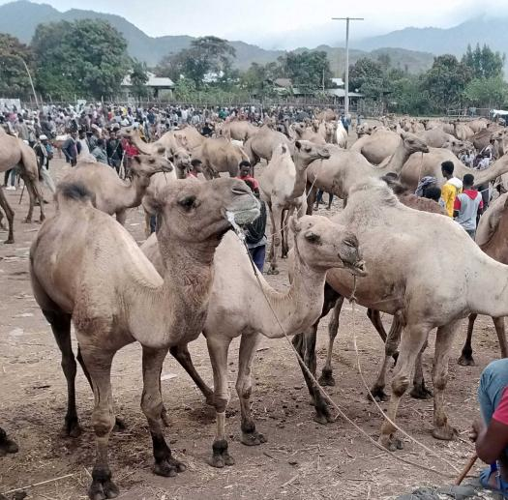 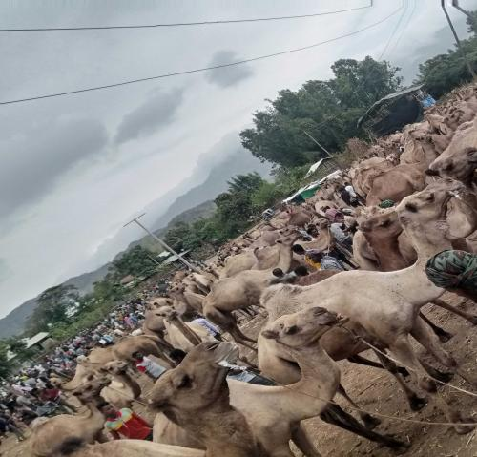

1 2

Figure.1and 2; Shows camels included in this study.

## 2.3. Study Design

A cross-sectional study was conducted from December 2023 to April 2024 to assess the prevalence of tick infestation and to identify the common tick species in the area that affects camel. Besides, favorable predilection site of the tick species, the relative tick burden and a possible risk factor such as age, treatment(dewormed and non dowermed) and body condition of the animal were considered.

## 2.4. Sample Size Determination

The sample size was determined based on the formula recommended by Thrusfield (2007) for simple random sampling method. Since there was no previous work done on this area, a 50% expected prevalence was used to calculate the required sample size. Therefore, the sample size in this study was calculated using the following formula.

N= 1.96 2(Pexp)­(1-Pexp)

D 2

Where, N = sample size required

1.96 = the value of Z at 95% confidence interval

Pexp = expected prevalence (50%)

D= desired absolute precision (5%)

Hence, the sample size required as per above formula was 384 camels.

## 2.5 Tick (Sample) Collection Techniques

Camels were examined carefully for ticks with the help of the camel owners. Predilection sites for ticks, such as the head, neck sternum, under tail, ventral, scrotum/udder, and back/side surface of the body of the animals were carefully examined by visual inspection and palpation of skin. All visible adult ticks attached on these areas of animal bodies were collected carefully and gently removed. Then the collected ticks were preserved in properly labelled tick collection bottle containing 70% alcohol. The bottles were labelled with date of collection, place, age and site of the body and then transported to Woldia University Microbiology Laboratory for tick identifications.

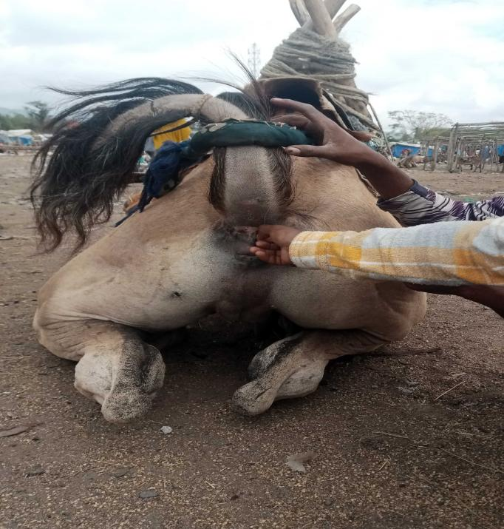 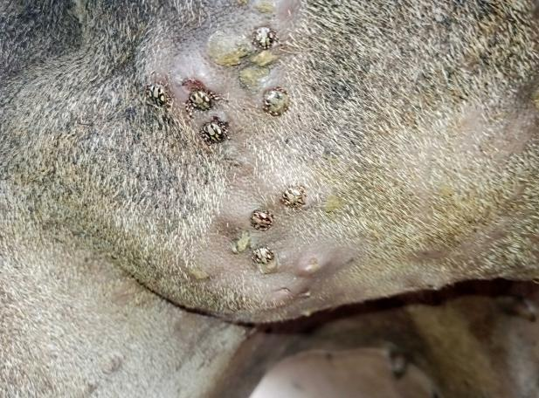

3 4

Figure. 3: Show the hand collecting of ticks from infested camel

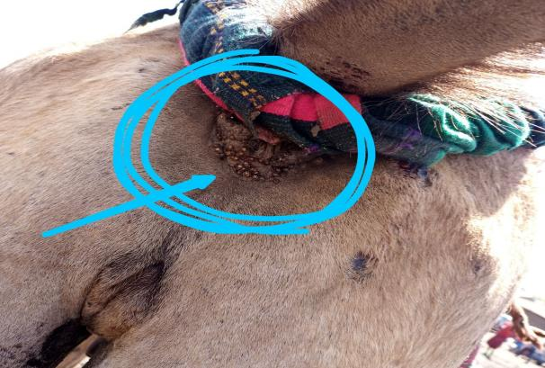 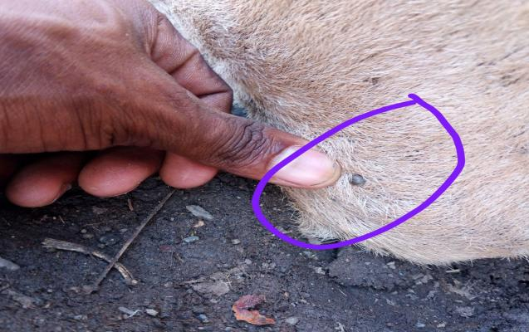

5 6

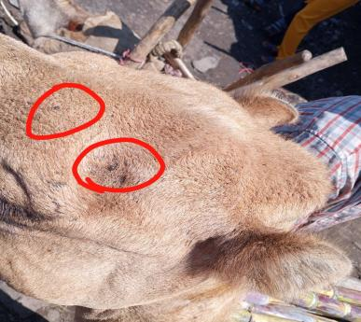 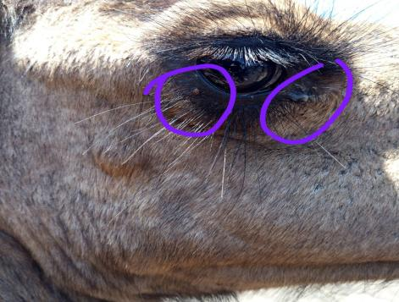

7 8

Figer.4,5 ,6,7,&8: Shows ticks in different sites of infested camel.

## 2.5 Tick Identification

The collected ticks from each bottle were placed onto Petri dishes and examined under stereomicroscope to identify to the species level using tick identification keys described by Walker et al., (2003). Briefly, the main identification features of the ticks were scutum, anal groove, festoon (ornamentation), colour, size, shape of mouthparts, and legs colour.

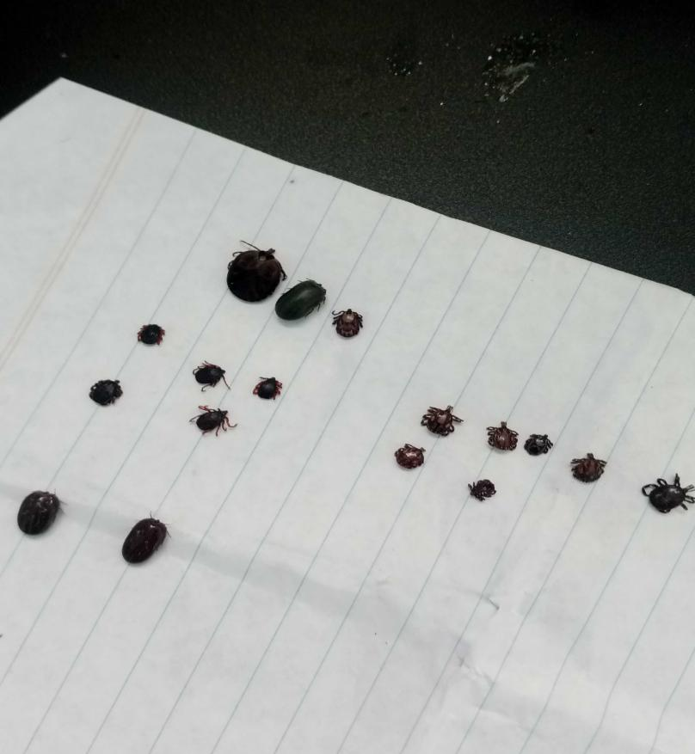

Figer. 9: Shows sample of collected ticks from the camels.

## 2.6. Data Management and Analysis

Data obtained in this survey was entered in MS Excel work sheet and analysed using STATA® version 11, for windows software. Simple descriptive statistical analysis was used to analyse prevalence of tick species and its attachment site. Chi-square test (ᵪ2) was applied to compare the infestation rate with regard to age, sex, origin, and body conditions. A 95% confidence interval and a 5% absolute precision level were used to determine whether there was significant difference between measured parameters.

# 3. RESULTS

Out of 384 examined camels, 212 (55.21%) were found to be infested by ticks. A total 1008 Ixodid ticks were collected among which four Ixodidae tick genera and seven species namely A. variegatum, A. lepidium, H. dromedary, H. marginatumrufipes, H. truncatum, Rhip(Bo). decoloratus, and Rhip. pulchelis were identified from the study area. From a total of 384 camels examined for tick, 154 were dewormed for external parasites and 230 non dewormed, according to their age 84 camels were up to3 years age (young), 188 camels were between 4-6 years (adult) and 112 camels >6 years (old) again 64 poor, 190 medium and 130 good body condition score cattle were considered for this study.

## 3.1 Prevalence of Hard Tick Infestation Considered With Risk Factors

**Age:** from 384 examined camel’s, 112(29.17%) are old, 188(48.96%) are adult and 84(21.88%) are young. From 112 old camels 62(55.35%) were found to be positive for tick infestation. while from 188 adult animals 115(61.17%) were found to be positive and from 84 young animals 35(41.67%) were found to be positive. There was no statistically significant variation detected between age groups (p> 0.05) and rate of tick infestation (Table 1).

Table 1: Prevalence of tick infestation based on age categories

|  |  |  |  |  |  |
| --- | --- | --- | --- | --- | --- |
| Age | Total No examined | No of positive  (%) | p-value | Odd ratio | 95% CI [Lower-Upper] |
| Young | 84 | 35 (41.67%) |  |  |  |
| Adult | 188 | 115(61.17%) | 0.151 | 1.528602 | 0.8568521-2.726987 |
| Old | 112 | 62 (55.35%) | 0.027 | 2.061928 | 1.087865-3.908155 |
| Total | 384 | 212(55.21%) |  |  |  |

**Body Condition:** According to body condition scoring (BCS), camels were grouped into three namely: good, medium and poor, with infestation rate of 42.3%, 60% and 67.19%, respectively. There was statistically significant difference [p=0.000] in infestation rate among camels that have different body conditions (Table 2).

**Table2**: Prevalence of tick infestation on camels of different body condition categories

|  |  |  |  |  |  |
| --- | --- | --- | --- | --- | --- |
| BSC | No examined | No of positive  (%) | p-value | Odd ratio | 95% CI  [Lower-Upper] |
| Good | 130 | 55 (42.3%) |  |  |  |
| Medium | 190 | 114 (60%) | 0.000 | 3.033438 | 1.797584-5.118952 |
| Poor | 64 | 43 (67.19%) | 0.000 | 3.688452 | 1.85177-7.346851 |
| Total | 384 | 212(55.21%) |  |  |  |

**Treatment:** Regarding treatment, 154 are treated (dewormed) and 230 are non-dewormed camels were examined, out of which 50 (32.46%) and 162 (70.43%) were infested by different ticks species, respectively. The difference in tick infestation rate between treatment groups was statistically significant (p=0.00) (Table 3).

**Table 3:** Prevalence of tick infestation based on treatment categories

|  |  |  |  |  |  |
| --- | --- | --- | --- | --- | --- |
| Treatment | No examined | No of positive  (%) | p-value | Odd ratio | 95% CI  [Lower-Upper] |
| Dewormed | 154 | 50 (32.46%) |  |  |  |
| Non deworm | 230 | 162 (70.43%) | 0.000 | 0.1566916 | 0.0955312-0.257007 |
| Total | 384 | 212 (55.21%) |  |  |  |

**Table 4:** The association of the host risk factors (variables) with the presence of the ticks by using multivariable logistic regration analysis

|  |  |  |  |  |  |  |
| --- | --- | --- | --- | --- | --- | --- |
| Variables | Catago  ries | N | NPA (%) | P-value | OR | 95% CI  [Lower-Upper] |
| Age | Young | 84 | 35(41.67%) |  |  |  |
| Adult | 188 | 115(61.17%) | 0.151 | 1.52860 | 0.8568521-2.726987 |
| Old | 112 | 62(55.21%) | 0.027 | 2.061928 | 1.087865-3.908155 |
| BCS | Good | 130 | 55(42.3%) |  |  |  |
| Medium | 190 | 114(60%) | 0.000 | 3.033438 | 1.797584-5.118952 |
|  | Poor | 64 | 43(67.19%) | 0.000 |  | 1.85177-7.346851 |
| Rx | Deworm | 154 | 50 (32.46%) |  |  |  |
| Non deworm | 230 | 162 (70.43) | 0.000 | 0.1566916 | 0.0955312-0.257007 |
| Total |  | 384 | 212(55.21%) |  |  |  |

**NB:** N=total number of examined animal,

NPA=number of positive animals

OR=odds ratio

CI=confidence interval

BSC=body condition score

Rx=treatment

## 3.2 Tick Burden and Species Identification in Study Area

In the survey, a total of 1008 adult ticks were collected from different body regions of 384 examined camels. Seven tick species belonging to four genera were collected in the district. The abundant tick genera identified were Hyalomma 457 (45.354%) followed by Amblyomma 274 (27.18%), Rhipicephalus 218 (21.63%), and Rhipicephalus (Boophilus) 59 (5.85%). Specifically the identified species were: Hyalomma dromedarii, Hyalomma truncatum, Hyalomma marginatum rufipes, Amblyomma variegatum, Amblyomma lepidium, Rhipicephalus pulchellus (Boophilus) decoloratus and Rhipicephalus pulchellus (Table 5 & 6).

**Table 5:** Distribution of camel ticks genera in the study area

|  |  |  |
| --- | --- | --- |
| Tick Genera | Total No.of Ticks | Relative Prevalence |
| Hyalomma | 457 | 45.35% |
| Amblyomma | 274 | 27.18% |
| Rhipicephalus | 218 | 21.63% |
| Rhipicephalus (Boophilus) | 59 | 5.85% |
| Total | 1008 | 100% |
|  |  |  |

Hayalomma dromedarii was the most abundant tick species and it represents 291 (28.7%) of the total collected ticks followed by A.varigatum 232 (23.02%), Rh.pulchelis 218 (21.63%), H.truncatum 93 (9.23%), H.rufipes 73 (7.24%), Rh (Booph).decoloratus 59 (5.85%), and A.lepidium 42 (4.2%) (Table6).

**Table 6:** Ticks species, sex ratio and percent of abundance

|  |  |  |  |  |  |
| --- | --- | --- | --- | --- | --- |
| Tick Species | No. of Male | No.  of Female | Total | Female to Male  ratio | Prevalence |
| Am.Variegatum | 139 | 93 | 232 | 1:1.49 | 23.02% |
| Am.Lepidi | 24 | 18 | 42 | 1:1.3 | 4.2% |
| Hy.Dromedarii | 172 | 119 | 191 | 1:1.3 | 28.87% |
| Hy.Truncatum | 56 | 37 | 93 | 1:1.5 | 9.23% |
| Hy. M. rufipes | 50 | 23 | 73 | 1:2.17 | 7.24% |
| Rh (B). decoloratus | 21 | 38 | 59 | 1:0.55 | 5.85% |
| Rh.Pulchillus | 125 | 93 | 218 | 1:1.3 | 21.63% |
| Total | 587 | 421 | 1008 | 1:1.39 | 100% |

The current study indicated that every tick species prefers different attachment sites. Among those ticks attachment site, Tail (30.06%), was the most preferred sites followed by Scrotum (27.28%), Inguinal (13.79%), Sternum (9.33%), Head (5.16%), Ventral (5.06%), Eye (4.86%), and Neck (4.46%) (Table7).

**Table 7:** Distribution of ticks species and proportion in different attachment site

|  |  |  |  |  |  |  |  |  |  |
| --- | --- | --- | --- | --- | --- | --- | --- | --- | --- |
| Attach-ment  Site | A.vari-  gatum | A.lepi-  dium | H.dro-  medarii | H.ru-  fipes | H.Trun-  catum | Rh(Bo).de-  coloratus | Rh.pul-  lchillus | Tot-  al | Preva-lence |
| Tail | 77 | 12 | 86 | 21 | 42 | 9 | 56 | 303 | 30.06% |
| Scrot-  um | 62 | 13 | 78 | 25 | 30 | - | 67 | 275 | 27.28% |
| Ingui-  nal | 43 | 12 | 41 | 10 | 12 | - | 21 | 139 | 13.79% |
| Stern-  uml | 25 | 5 | 35 | 8 | 4 | - | 17 | 94 | 9.33% |
| Head | - | - | 24 | - | - | 13 | 15 | 52 | 5.16% |
| Ventr-  al | 19 | - | 7 | - | 5 | 7 | 13 | 51 | 5.06% |
| Eye | - | - | 6 | 9 |  | 11 | 23 | 49 | 4.86% |
| Neck | 6 | - | 14 | - | - | 19 | 6 | 45 | 4.46% |
| Total | 232 | 42 | 291 | 73 | 93 | 59 | 218 | 1008 | 100% |

# 4. DISCUSSION

Ticks are one the chief external parasites that distressing all animals including camels. They effect on the health of the animals and able to spreading different diseases causing agents. Moreover, ticks are sucked the blood and cause anemia due to loss of the blood. They are also damaged the hide and skin of the animals (Teka et al., 2017; Al Salihi et al., 2017; Walker et al., 2003). The camel productivity are reduced due to ticks infestation, moreover heavy ticks infestation are causing a significant economic loss (Zeleke and Bekele, 2004). The results of the present study revealed that the Camelus dromedarius surrounded in habru district were infested by different species of ticks.

In the present study, the overall prevalence of tick infestation in the study area was 55.21%. This finding was almost compatible (agree) with Eyerusalem (2008) in Dire Dawa, who reported 58.3 %, Dinka et al., (2010) who reported 61.46% in Eastern Ethiopia, Shubber et al., (2014), who reported 65.77 % of tick infestation and disagree with Ayele and Mohamed (2013), Farah et al , (2017), Zelalem and Abdulkadir (2020), Hagazi et al , (2004), who reported 94%, 97%, 95.3%, 2.46% respectively.

The reason for different prevalence in different study might be associated with different topography of the area, difference in sample size, difference in season of examination, presence or absence of seasonal deworming, temperature difference, different humidity, level of immunity of the animal, amount of rainfall that the areas are receiving, nutritional status of the animal, different management system in different area, awareness of farmers about parasitic infection.

The finding of this study in showed that there was statistically significant association (p<0.05) between tick infestation rate and body condition of the camels. The tick infestation rate was higher in camels with poor body condition score (BCS) (67.19%) followed by camels with medium BCS (60%) and good BCS (42.3%). This is agree with The higher prevalence in poor body conditioned animals may be due to poor body condition animals have ruffled hair coat that allows ticks to penetrate hair and attach the skin of animal easily and high infestation of tick result in poor body condition due to consumption of high amount of blood by those ticks.

In this study, about 1008 ticks were collected which belongs to four genera of ticks (Ambylomma, Hyalomma, Rhipicephalus (Boophilus) and Rhipicephalus) and seven species namely *Rh. pulchellus, Hy. dromedarii, Hy. truncatum, Hy. rufipes, Am. variegatum, Am. lepidium* and *Rh* (*Bo*)*. decoloratus.* Except *Am. lepidium* this result was in agreement with the finding of Ayele and Mohammed (2013) on a study of camels’ ticks in and around Dire Dawa, Eastern Ethiopia. The presence of similar tick species in the districts may be due to unrestricted camel movement from area to area, which is a common phenomenon in the region.

*Hy. dromedarii* was the first predominant species infesting on camel in the current study area. With relative proportion of 28.7%, this result was in agreement with the finding of Eyeruselam (2008), who reported 26.8%, Ayele and Mohammed (2013) were reported 26.85% and Abeba (2001) reported 20.4% and there is slight difference with the finding of Dinka et al., (2010) and Eyeruselam (2008) were reported 15.36% and 15.4% respectively. On the other hand it is higher than the study of Bekele (2010) and Zeleke and Bekele (2004) were reported 1.2% and 3.87% respectively from Ethiopia and much lower than the studies from other researchers Farah et al., (2017) and Mohsen et al., (2013) were reported 56.8% and 90.7% respectively. This difference might be due to management, agro-ecological and geographical difference. Camels are the preferred hosts of *Hy. dromedari*i (Walker et al., 2003).

*Am.vaigatum* (23.02%) was the second most abundant tick species found in the study area. This finding was in consistent with the finding of Hamza et al., (2019) who reported 21%. In contrast, it was greater than the finding of Abdullahi et al., (2018) who reported 15.2% in Nigeria, Hussen and Agonafir (2018) who reported 6.2% in Jijjiga, Ayele and Mohammed (2013) were reported 2.59% in Dire Dawa. The ulcer caused by this tick species become favorable site for secondary bacterial infection like Dermatophylus congolensis. A*. variegatum* has a great economic importance on cattle, because it has association with heart water (Cowdrosis) (Walker et al., 2010).

*Rh. Pulchelus* (21.63% ) was the the third most abundant tick species found in the study area. which is lower to the finding of Hussen and Agonafir (2018) were reported 37.5% in Jijjiga, Abebe (2001) and Ayele and Mohammed (2013) were reported a prevalence of 50%, and 46.8%, respectively. However, this finding is higher than the finding of Hamza et al., (2019) who reported 5.3% in Somalia. *Hy. truncatum* was among the moderately abundant tick species with a prevalence of 9.23%% in the study area, followed by *Hy. m. rufipes* and *Rh (Bo) decoloratus* which was found almost similar infestation rate, that were 7.24% and 5.85% respectively. This agreed with finding of Ayele and Mohammed (2013) in Ethiopia and that of Maha et al. (2010) in Sudan.

*Am. lepidum* was the least abundant thick in the study area. It accounts only 4.2% of the total coverage this finding is agree with the finding of Hussen and Agonafir (2018) were reported 4.6%. Little abundance of these species might be associated with availability of suitable hosts since it prefers a cattle or the climatic factor in the study area. This tick transmits the Cowdria ruminantium, which causes heartwater and the protozoans Theileria mutans and Theileria velifera which cause benign bovine theilerioses (Walker et al., 2003). The great variation of tick burden in different countries (areas) may be due to application of acaricides and Ivermectin, management practice, production system factors, agro-ecological, geographical difference, seasonal availability and climatic condition in the pastoral areas.

Concerning ticks predilections sites, the attachment site for ticks is related to the possibility of penetration by their hypostome. like Rhipicephalus attach to the thin skin (ear, head, under tail, margin of anus) whereas long mouthed ticks (Ambylomma and Hyalomma) can attach at the ticker skin (ventral, sternum and udder) (Ayele and Mohammed 2013). A verity of factors such as host density, interaction between tick species and inaccessibility for grooming determine the attachment site of ticks (Gebre et al., 2001).

With regarding of male to female ratio; in all cases, except for B. decoloratus, males outnumbered females; this is most probably because of fully engorged female ticks drop off to the ground to lay eggs while males tend to remain on the host up to several months later to continue feeding and mating with other females on the host before dropping off (Abebaw, 2004). Host grooming easily removes semi- engorged or engorged females as compared to males. The females of B. decoloratus outnumbered males in this study probably due to the small size of the male which could not be seen and this might be one of the contributory factors for missing of males (Ayana, 2013). Similar report was indicated in the country by (Ayele and Mohammed, 2013; Ayana, 2013; Solomon et al., 2003 and Desie, 2005).

.

# 5. CONCLUSION AND RECOMMENDATIONS

# 6. REFERENCES

Abdullahi, Y.M., Magami, I.M., Audu, A. and Mainasara, M.M., 2018. Prevalence of ticks on camels and cattle brought to Dodoru market Kebbi state, Nigeria. *Traektoriâ Nauki= Path of Science*, *4*(4), pp.3001-3004.

Abebaw, G. K. (2004): Seasonal dynamics of ticks (Amblyomma cohaerens and Boophilus decoloratus) and development of a management plan for tick and tick born diseases control on cattle in Jimma zone, south western Ethiopia. Ethiop. Vet. J., 18: 19-28.

Abebe, F. (2001): Prevalence and intensity of ectoparasite in infestation in Issa camels, Easten Ethiopia. DVM thesis, Faculty of Veterinary Medicine, Addis Abeba University, Debre Zeit, Ethiopia.

Al-Salihi KA, Abdullah S, Amjad L, Leitha H (2017). Epidemiological study of clinical and subclinical mastitis in she- camel in Samawah desert / Al Muthanna governorate. MRVSA. 6(2): 11-24.

Al-SalihiKarima (2016). Observations on dromedary (Arabian camel) and its diseases.MRVSA 5 (Special issue) 1st Iraqi colloquium on camel diseases and management.1-11.

Ayana, D., Eshetu, E., and Abunna, F. (2013): Survey of Ixodid Ticks on Cattle in Borana Pastoral Area, Ethiopia. Acta Paras. Glob. 4 (1): 14-23.

Ayele Taddese and Mohammed Mustefa (2013) A Study on Camels Ticks in and Around Dire Dawa, Eastern Ethiopia Unit of Basic Veterinary Sciences, Faculty of Veterinary Medicine, University of Gondar.

Ayele, T., and Mohammed, M. (2013): A Study on Camels Ticks in and Around Dire Dawa, Eastern Ethiopia. ActaParas.Glob. 4(2): 64-70.

Bekele, T. (2010): Milk production, fluid balance and temperature regulation in lactating camels (Camelusdromedarius). DVM Thesis, Swedish University of Agricultural Sciences, Uppsala.

Central Statistics Authority (CSA), (2014): Agricultural sample survey Report on livestock and livestock characteristics. Stat. Bullet, No. 446

CSA (Central Statistical Authority) (2013): Report on Federal Democratic Republic of Ethiopia, Agricultural Sample Enumeration Statistical abstract. Addis Ababa, Ethiopia.

Desie, S. (2005): Cattle Tick Dynamics in Different Agro-Ecological Zones of Wolayta, Southern Ethiopia. MSc thesis, Addis Ababa University, Faculty of Veterinary Medicine, Debre Zeit, Ethiopia.

Dinka, A., Eyerusalem, B., and Yacob, H. T. (2010): A study on major ecto-parasites of camel in and around Dire Dawa, Eastern Ethiopia. Revue Vet. Med., 11: 498-501.

Eyeruselam, B., 2008. Study on major Ecto-parasites of Camels in and around Dire Dawa, Ethiopia. DVM Thesis, FVM, AAU, Debre Zeit, Ethiopia

Farah Isse, A.S. and Ali, M., 2017. Hard tick distribution of camels in and around Galkaio District, Somalia. *Global J Med Res*, *17*, pp.6-11.

Farah Isse, Ahmed Saed & Mahdi Ali (2017): Hard Tick Distribution of Camels in and Around Galkaio District, Somalia

Franklin W L. (2011). Family Camelidae (Camels). In: Wilson DE, Mittermeier RA, editors. Handbook of the mammals of the World.Vol. 2.Hoofed mammals. Barcelona (Spain): Lynx Ediciones. 206-246.

Gebre, S., Nigist, M., and Kassa, B. (2001): Seasonal variation of ticks on calves at Sebeta in western Shewa Zone. Eth. Vet. J., 7(1,2): 17-30.

Hamza.H.S., Rahman.S.G., Sead.A., Risak.A.A, A/Nazir.B&Mahad(2019): Prevalence of tick infestation in dromedary camels (camelus dromedarius) brought for slaughter in Mandeeq abattoir, Hargeisa Somalia. World Journal of Pharmacy and Pharmaceutical Sciences

Hegazy AA, Fahmy LS, Aiad MA, Shamaa AA (2004). Eye Affection Among camels in Egypt. (2) pathological studies. J. Camel Sci. 1: 107-113

Hussen, A.H. and Agonafir, A., 2018. A study on ticks affecting camels (Camelus dromedarius) in Jigjiga district of Somali region, Eastern Ethiopia. *Int J Adv Res Biol Sci*, *5*(9), pp.121-130.

Kassa, B. (2005): Standard Veterinary Laboratory Diagnostic Manual, Veterinary Diagnostic Laboratory, College of Veterinary Medicine at the University of Illinois at Urbana, IL., USA.

Lodos, J., Boue, O. and Fuente, J., (2000): Model to simulate the effect of vaccination against Boophilus ticks on cattle. Vet. Parasitol, 87: 315-326.

Maha, A. El Tigani, and Mohammed, A. S. (2010): Ticks (Acari: Ixodidae) Infesting Camels in El Butana Area, Mid-Central Sudan. J. Vet. Res. 25: 51-54.

Mohsen, C., Gholamreza, M., Sadegh, C., Gholamreza, R., Ehsan, M., and Tahmineh, J. (2013): Frequency of hard-ticks and the influence of age and sex of camel on ticks infestation rates in one-humped camel (Camelus dromedaries) population in the northeast of Iran. Sci. Parasitol 14(2): 89-93

Mullen GR, Durden LA (2009). Medical and veterinary entomology. Academic Press, Burlington, MA

Pavlovic, I., Ivanovic S., Dimitric, A., Vegara, M., Vasic, A., Zivkovic, S. and Mijatovic, B., (2016): Tick population in goats and sheep in Љabac. Macedonian. Vet. Review 39: 103-109. Wall, R.; Shearer, 2001.D. Veterinary Ectoparasite, Biology, Pathology and Control.2nd ed.; Blackwell science limited, UK, 2001; P. 262.

Scwartz, 2001.Borreliaburgdorferi infectivity and maintenance in the camele tick infectious cycle. England, pp: 115-121.

Shubber HWK (2014). Taxonomic, anatomic, and molecular study of ixodid ticks parasitizing some mammals and birds in the middle and south of Iraq. Ph.D. thesis, College of Education, Al-Qadisiya University, Iraq

Sileshi, M., Moges, W. and Solomon, G., (2014): Ticks infesting domestic and wild animals in the tropics (Ethiopia) and their possible roles in disease transmission, Addis Ababa, Ethiopia. Nova Sci Publ, pp, 77-92

Solomon, G., Nigist, M., and Kassa, B. (2003): Seasonal Variation of ticks on Calves at Sebeta in Western Shewa Zone. Ethiop. Vet. J., 7: 17-30

Teka F, Mulisa M, Keder M, Yonas G, Tewodros A (2017). Major Ectoparasites Infesting Camelus dromedarius in Three Districts of Somali Regional State, Eastern Ethiopia. World Appl. Sci. J. 35 (1): 96-103

Thrusfield, M., 2007. Veterinary Epidemiology. 3 ed. Singapore: Blackwell Science, pp: 233.

Walker A.; Camicas, J.L.; Estrada-Pena, A.; Horak, I.G.; Latif, A.A.; Pegram, R.G. & Preston, P.M. Ticks of Domestic Animals in Africa. A Guide to Identification of Species, 2003, Bioscience Reports, Edinburgh.

Walker AR, A Bouattour, JJ Camicas, PA Estrada, IG Horak, AA Latif, RG Pegram, PM Preston (2003). Ticks of domestic animals in Africa: A Guide to Identification of Tick species. Biosci. Rep. Pp: 1-122.

Walker, A.R., A. Bouattour, J.J. Camicas, A. Estrada Pena, I.G. Horak, A.A. Latif, R.G. Pegram and P.M. Preston, 2003. Ticks of domestic animals in Africa: A Guide to Identification of Tick species. Bioscience Report, pp: 1-122

Wall, R.; Shearer, D. Veterinary Ectoparasite, Biology, Pathology and Control.2nd ed.; Blackwell science limited, UK, 2001; P. 262.

Zelalem Abera and Abdulkadir Hussein (2020): Prevalence of Camel Ticks in Berbere District, Bale Zone, South East Ethiopia European Journal of Biological Sciences 12 (2): 64-70.

Zeleke M, Bekele T (2004). Species of ticks on camels and their seasonal population dynamics in Eastern Ethiopia. Trop. Anim. Hlth. Prod. 36: 225-231.

Zeleke, M. and Bekele, T, (2004); Species of ticks on camels and theire seasonal population dynamics in Eastern Ethiop.*Tropical animal health and production*, **36(3**), 225-231